ROVotron RVCBOT-D Control

Board Kit Assembly Guide

Getting started
The ROV control board is called RVCBOT-D. This board is the brains of the ROV. A picture is included to show you what the completed board will look like after assembly. Please refer to this photo if you don’t understand the written instructions about how to assemble the board.

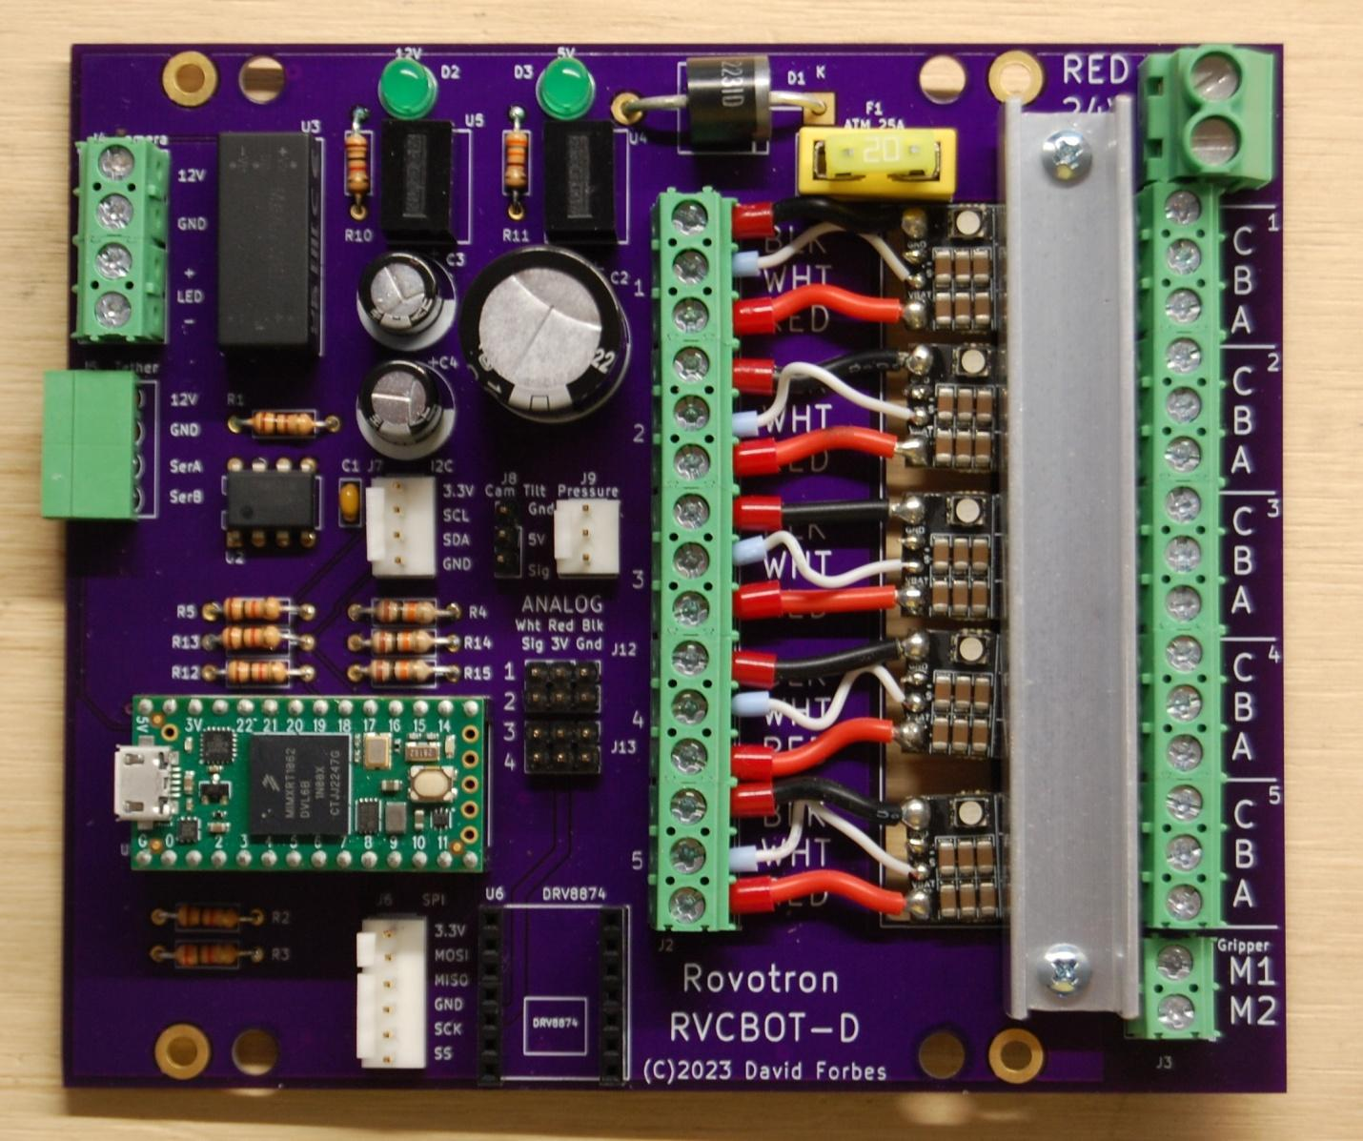

Experience required
These instructions assume that the builder has experience soldering through-hole parts onto a printed circuit board.
Building the Rovotron Control Board RVCBOT-D takes a couple of hours. It’s best to follow the instructions carefully, because there are many details of robot construction that can be done wrong and will cause you grief later. This kit and instructions have been meticulously created to allow you to succeed in getting a fully functioning ROV into the water and driving around.
It’s tempting to take shortcuts or to think that you know what comes next. Please resist that temptation. The experience of the kit designers has shown that shortcuts lead to failure.

Tools required
Tools needed
Soldering iron, fine tip, adjustable temperature preferred
Small diagonal cutters
Small long-nose pliers
#1 Phillips screwdriver
Wire strippers 16-24 AWG e.g. Ideal 45-416
Ferrule crimper

Supplies required
Solder, high quality lead-free or leaded .031" diameter or smaller, rosin or no-clean flux

Time required
The Control Board kit will take several hours to assemble. Take your time. When you stop for the day, be sure to keep all the parts safe and together with the kit, so that none are lost or borrowed.

Parts List
The parts supplied in the kit are listed below in order of installation. Check that all parts are included in the kit. Contact the supplier if there is a shortage.
In the list below, 'Step' refers to the assembly sequence. 'Marking' refers to any part number printed on the part itself. The assembly instructions begin after the parts list. Note that some parts may be confused, as they have very similar appearance. The resistors have color codes to that require careful attention to tell apart, and the two voltage regulators have slightly different part numbers.

Step | Qty | Description | Designators | Markings TV
1 | 1 | Res 100 1/4W | R1 | Brn-Blk-Brn-Gold
2 | 5 | Res 1K 1/4W | R2, R5, R10, R12, R13 | Brn-Blk-Red-Gold
3 | 1 | Res 2K 1/4W | R3 | Red-Blk-Red-Gold
4 | 3 | Res 10K 1/4W | R4, R14, R15 | Brn-Blk-Org-Gold
5 | 1 | Res 330 1/4W | R11 | Org-Org-Brn-Gold
6 | 1 | Capacitor, 0.1uF | C1 | 104M
7 | 1 | IC, RS-485 transceiver | U2 | SN75176BP
8 | 1 | Header 4 pin RA | J5 | Green
9 | 1 | Fuseholder | F1 | Yellow
10 | 2 | LED | D2,D3 | Green
11 | 2 | Socket strip | U1 | Black 14 pin
12 | 2 | Socket strip | U6 | Black 7 pin
13 | 1 | Diode 6A 100V | D1 | GI751
14 | 1 | Regulator, LED | U3 | LDD-500L
15 | 1 | Header, 24 pin | J8, J12, J13 | black 24 pin
16 | 1 | Regulator, 5V | U4 | R-78K5.0-1.0
17 | 1 | Regulator, 12V | U5 | R-78K12-0.5
18 | 1 | Header, Molex 6 pin | J6 | White 6 pin
19 | 1 | Header, Molex 4 pin | J7 | White 4 pin
20 | 1 | Header, Molex 3 pin | J9 | White 3 pin
21 | 3 | Terminal block | J3,J4 | Green 2 pin
22 | 10 | Terminal block | J2,ESCs | Green 3 pin
23 | 2 | Capacitor, electr | C3, C4 | 470uF16V
24 | 1 | Terminal block | J1 | Green 2 pin tall
25 | 1 | Capacitor, electr. | C2 | 2200uF35V
26 | 1 | Fuse ATM 20A | F1 | Yellow 20
27 | 1 | Microcontroller | U1 | Teensy4.0
28 | 5 | Speed controller | ESCs | ESC 6S 35A
29 | 12 | Ferrule big | ESCs | 17 AWG
30 | 6 | Ferrule small | ESCs | 23AWG
31 | 1 | Tape, foam | ESCs | Red roll
32 | 1 | Heat sink | ESCs | 1/2x1/2 C channel
33 | 24 | Screws heatsink |  | 4-40x1/2 pan Phillips
34 | 24 | Nuts heatsink |  | 4-40 square

Step by step guide
Since the ROV has a transparent case, the effort you put into making sure that all the parts are installed neatly will be reflected every time you or someone else looks at the ROV. For this reason, it is recommended that you take your time to ensure that every part is aligned straight before soldering the second pin. You can reheat a pin and move the part with your fingers to align it properly. This is the method used for the factory-assembled boards.

0) The circuit board has a Top and a Bottom. The Top has the markings outlining where the parts go. The parts will be installed from the Top, with their leads or pins poking through the holes, and then soldered from the Bottom.

1 through 5) Install the resistors. First, sort them by color code according to the parts list above. Use a bright light to be able to see the colors easily, as they are similar. Bend the leads on each resistor at a 90-degree angle and insert them into the holes. It does not matter which lead goes in which hole on each resistor. Bend the leads outward at about a 30-degree angle to hold each resistor in place. Solder one lead to the PC board then look to see that the resistor is straight, then solder the other lead. Trim both leads with cutters.

6) Install the tiny capacitor C1. It does not matter which lead goes in which hole. Solder, then trim the leads.

7) Install the U2 Transceiver chip next. You might need to very carefully bend the leads inward a bit to get it to drop into the holes in the board. Make sure to align the molded dot with the square solder pad. This is at the end of the part outline that has a notch in it, next to the printed U2 symbol. After inserting the chip, bend two opposite corner leads outward at an angle, to hold it in place for soldering. Solder the eight leads. They do not need to be cut off after soldering.

8) Install the Tether header J5. The open end of the connector will hang over the edge of the circuit board. These pins are too short and stiff to bend, so let the weight of the circuit board hold the part in position as you solder the pins completely. They do not need to be trimmed.

9) Install the yellow fuse holder for F1. Solder one pin, then make sure it's straight, and solder the remaining pins.

10) Install the two green LEDs D2 and D3. Each has a flat side at the base, and the shorter lead is on this side, which goes towards the edge of the circuit board. Make sure the shape of the part matches the printed shape on the circuit board. Bend the leads outward to hold the parts in place, solder, and trim the leads.

11) Install and solder the long socket strips for U1 next. Place one strip in the board, turn it over and solder one pin in the center of the strip. Then turn the board over and make sure that the strip is straight and fully seated, heating the soldered pin as needed to adjust it. Then solder the remaining pins. Repeat with the other strip.

12) Install and solder the shorter socket strips for U6 next, following the previous instructions.

13) Install the diode D1. Bend the legs to a 90-degree angle first, forming a smooth radius. Install the diode with its striped end over the stripe shown on the board. Bend the legs apart at a 30-degree angle to hold it in place while you solder it. Trim the excess leads with diagonal cutters.

14) Install the LED regulator, using the number of pins on each and to orient it properly. If you place a small object under the opposite corner of the circuit board, this will let the board rest on the regulator, keeping the pins in place while soldering the pins. You may also bend two opposite corner pins outward a bit. The leads do not need to be trimmed.

15) Install and solder the five, three pin headers J8, J12, and J13. Solder the center pin of each first, and ensure it is fully seated and straight. If not, heat the solder and straighten. Then solder the remaining pins.

16) Install and solder the 5V regulator U4 next. Be sure to orient the part with the leads offset as shown on the board. There is a dot printed on the part at the 1 pin, which should be in the hole with a square solder pad. Double check that the part with 5 in the part number is closest to the green LED marked 5V. Check and adjust the parts’ alignment after soldering the center pin, before finishing the soldering work.

17) Install and solder the 12V regulator U5. Be sure to orient the part with the leads offset as shown on the board. There is a dot printed on the part at the 1 pin, which should be in the hole with a square solder pad. Double check that the part with 12 in the part number is closest to the green LED marked 12V. Check and adjust the parts’ alignment after soldering the center pin, before finishing the soldering work.

18) Install the white 6 pin J6 connector. Make sure the locking tab is on the side with the line on the label on the circuit board. Solder a center pin first, make sure the part is straight and fully seated, and then solder the remaining pins.

19) Install the white 4 pin J7 connector. Make sure the locking tab is on the side with the line on the label on the circuit board. Solder a center pin first, make sure the part is straight and fully seated, and then solder the remaining pins.

20) Install the white 3 pin J9 connector. Make sure the locking tab is on the side with the line on the label on the circuit board. Solder the center pin first, make sure the part is straight and fully seated, and then solder the remaining pins.

21) Install the green J3 screw terminal block for the Gripper. Make sure the large opening for the wires is facing the outer edge of the circuit board, and solder the two pins. For the J4 Camera, look closely at the terminal blocks, and note that there are little ridges and grooves at the ends. Carefully slide one block onto the other, so they become a single piece. Once the two are assembled, insert into the circuit board, and solder the four pins.

22) Install the five green screw terminal blocks J2 for the ESCs. Before installing, connect all five blocks together into one piece. Look closely at the terminal block ends. Note that there are little ridges and grooves at the ends. Carefully slide one block onto the other, so they become a single piece. Once the five are assembled, insert into the circuit board, and make sure the large openings for the wires are facing the large slot in the circuit board. Solder one pin near the middle. Cbeck that the terminal block assembly is tight against the board and adjust if necessary by pushing the block against the board while heating the soldered pin. Solder the remaining pins.

23) Install and solder the 470uF electrolytic capacitors C3 and C4 next. Observe polarity! Note that the negative lead of the electrolytic capacitors is marked with a white stripe, and the PC board marks the negative hole with a white semicircle. The positive leads of the capacitors are longer and go into the holes marked with a + sign. Bend the legs apart to hold them while soldering. Solder one lead on each capacitor, then turn the board over and make sure the capacitors are both straight. Solder the other lead on each and trim the excess lead length.

24) Install the large green J1 screw terminal block. Make sure the large opening for the wires is facing the outer edge of the circuit board and solder the two pins.

25) Install and solder the 2200uF electrolytic capacitor C1 next. Observe polarity!
Bend the legs apart to hold them while soldering. Solder one lead, then turn the board over and make sure the capacitor is straight. Solder the other lead and trim the excess lead length.

Plug in Components
26) Install the yellow F1 Fuse into the Fuseholder. Make sure it seats all the way.

27) Install the U1 Teensy into the socket. Note that the USB socket on the Teensy board is oriented toward the outer edge of the main Control board. Be static cautious.

Electronic Speed Controllers
Prepare the four or five ESCs. If you have a strafing motor, you will have five ESCs, otherwise you will have four.
Each ESC is supplied with wires for the power and control input. Three wires need to be shortened, and ferrules installed. The small black wire needs to be cut off. There is a plastic wrapper that must be removed. And a terminal block needs to be soldered in place.
To remove the plastic wrapper, lay the ESC on one edge, and use an X-Acto knife to carefully cut the plastic along the edge of the circuit board. Go slowly and be very careful not to nick any parts on the circuit board. Peel the plastic sleeve off of the board.
Carefully measure the two large red and black wires out 1 inch from the edge of the circuit board and cut them off. Cut off the small black wire right next to the solder connection on the circuit board. Cut the small white wire a little longer than one inch.
Very carefully not to damage the wire strands, strip ¼ inch of the insulation off the ends of the red, black, and white wires.

Ferrules
Each ESC wire connection requires a stranded wire to be inserted into a screw terminal block. This can be difficult and may create short circuits between adjacent wires if any loose strands touch other wires or terminals. For this reason, a ferrule is crimped over each stranded wire end.

A ferrule looks like a small metal tube with a plastic funnel. There are several different sizes of ferrules provided. Each has a different color funnel, to make them easy to identify.
Wire sizes are measured in different ways. In most of the world, the wire cross section area is given in square millimeters, shown as mm². In the USA, wire sizes are given in the American Wire Gauge, or AWM. This is a bizarre numbering system that only makes sense if you manufacture wire, because it indicates how many times the wire was drawn through a drawing die to make it a bit smaller.

The ferrules used on the ESCs are:
24 AWG 0.25 mm² Blue Signal
18 AWG 1.00 mm² Red Power

Once the wires on the ESC have been stripped, you can install the three ferrules. Install a red ferrule on the black wire, make sure all the strands enter the funnel. With the ferrule in place so the wire strands are just at the end of the metal tube, place the ferrule in the crimping tool, and crimp. The tool will release after the crimp is fully made. Inspect to make sure the wire is still in place, and the crimp is sufficient to hold the ferrule on.
Repeat the red ferrule installation process on the red wire.
Install and crimp a small blue ferrule on the white wire.

Each ESC needs a 3 pin green terminal block soldered on the end that does not have wires. The block must go on the “top” of the ESC, this is the side with the metal plate and large printing. The terminal block must be oriented so the openings for the wires face away from the ESC.
Set the terminal block on your work table with the pins up, and place the ESC board on top of it, upside down, with the three holes in the end of the ESC sliding over the three pins on the terminal block. Check that the square holes in the terminal block are facing the outside, not the center of the ESC. Make sure the block is perpendicular to the circuit board, and solder the center pin to the board. Pick up the ESC and inspect that the block is in the correct position. If it is not, reheat the solder and correct. Once it is in its proper place, solder the remaining pins.

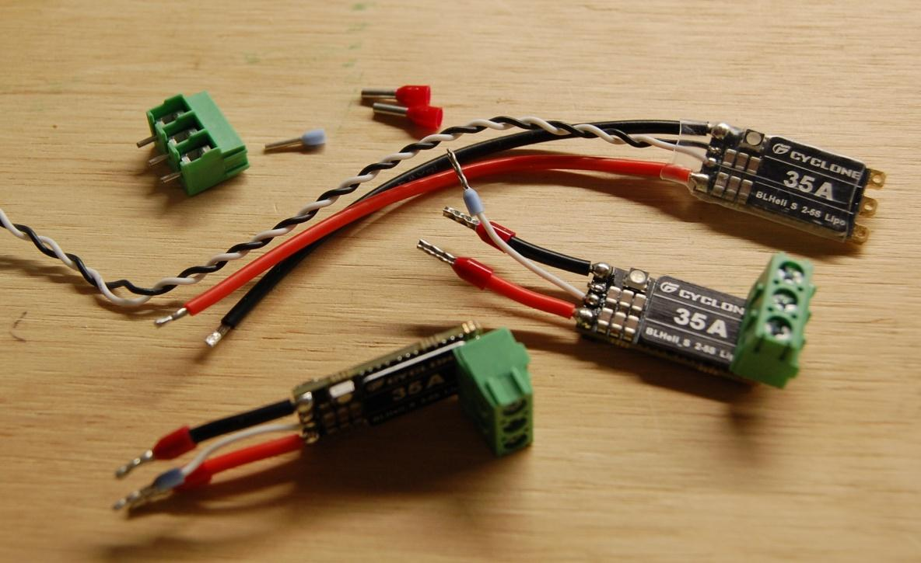

Repeat these steps with the remaining ESCs. If you damage a wire, you can use the cut off wires to replace it. Be very careful when unsoldering and soldering the wires, as the small circuit board is fragile.

31) Unroll about 4 inches from the roll of 3M foam tape. Try to not touch much of the sticky side as you do so. Apply the foam tape to the circuit board, so it covers the square blocks marked ESC. Cut off the excess tape. Remove the protective plastic from the tape.
Hold the first ESC above the RVCBOT board, next to the yellow fuse holder, so the ferrules on the three wires enter the holes in the terminal block J2. Verify the wire colors match the labels on the circuit board. Hold the ESC in position over the board so that the marked block with C B A is fully visible, not covered by the terminal block on the ESC. Carefully lower the ESC on to the tape. Press the ESC into the foam tape so that it is held in place. Use a 1/8” (3mm) slot screwdriver to tighten the three small slot head screws in the terminal block to retain the ferrules on the black, white and red wires.
With the next ESC, place the wires in the terminal block holes, then very carefully insert the terminal block tabs into the slots on the first ESC terminal block. Lower the second ESC down until it sticks to the tape. Make sure it is aligned well. Tighten the three terminal block screws to retain the wires.
Repeat with the remaining ESCs.

33 and 34) Install the aluminum heat sink bar over the ESCs with the side with the holes resting on the metal plates on the ESCs. Install a 4-40 x ½” screw and square nut at each end of the heat sink but don’t tighten them yet. Make sure the aluminum bar is not contacting any components on any of the ESCs. It should only contact the metal plates on top of them. Alternately tighten the screws gently, so the ESCs are snug.

Check that the assembly matches the photo at the beginning of the instructions.

